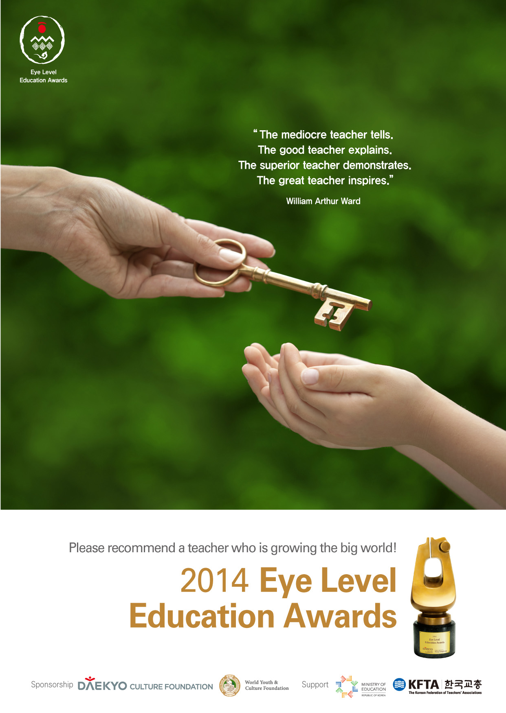

Eye Level Education Awards Information

1. Awards Categories and Awards Details
Category |  | Nominees |  | Awards Details
Foreign Educator | The United States  Indonesia  Malaysia  Hong Kong | Up to  4 Person | teacher or faculty, from elementary school to university | Medal, Certificate of award, a cash prize of USD15,000, and travel expense for award ceremony in Korea

2. Qualifications of Nominees
Foreign Educator | - Foreign(non-Korean) Teachers or faculty (from elementary school to university) who contributed to the diffusion of Korean education and/or culture in foreign countries  - Role model for teaching-learning method, curriculum development, research for education and  community service  - over 10 years’ experience in education field

3. Submission Documents
1) 1 copy of recommendation letter per nominee (provided form including a photo)
2) 1 copy of contribution essay (up to 5 pages)
3) Up to 30 pages of evidence documents

4. Submission of Recommendation Letter
1) Submission period : June 1, 2014 ~ July 31, 2014
2) Address for submission
- Daekyo USA (New York) 105 Challendar Road, Ridgefield Park, NJ 07660, U.S.A.
Tel: 1-201- 621-7780 Fax: 1-201- 498-1218
- Daekyo Malaysia 50-G-2 Wisma UOA, Jalan Dungun, Bukit Damansara, 50490 Kuala Lumpur, MALAYSIA
Tel: 60-3-2093-1909 Fax: 60-3-2093-2909
- Daekyo Indonesia JL.Gatot Subroto Kav.27, Menara Global 17B, 12950 Jakarta Selatan, INDONESIA
Tel: 62-21-5292-0911 Fax: 62-21-5292-0912
- Daekyo Hong Kong Rm 601, Island Place Tower, 510 King’s Road, North Point, HONGKONG
Tel: 852-2104-0188~9 Fax: 852-2104-0190
※Please download a recommendation letter form from the DAEKYO Culture Foundation website (www.dkculture.org/en/) or make a request
to the branch office in your country.

6. Screening Process
Local Screening ▶ Final Screening
※Screening Committee which consists of veterans of each field and educational experts appointed by DAEKYO Culture Foundation, will select awardees.

7. Awardees Announcement
In October 2014 – by personal contact and DAEKYO Culture Foundation Website (www.dkculture.org/en/)

How to write submission documents

1. Writing a recommendation letter for nominee
1) Fill in only one section in the recommendation category.
2) When describing teaching experiences, enter the actual teaching period (time off period should be excluded)
including the total period of working in educational career.
3) The recommender must briefly summarize reasons for recommendation in the reason for recommendation column.
4) The nominee’s educational background column should be started with high school.
5) Describe only major awards won by a nominee, and name of the awards giving body should also be stated.

2. Writing contribution essay abstract
1) Size and length of document
- Write major contributions in MS Word (less than 5 pages on A4 size), and submit the document on a USB drive
(must be conformed to the determined size and length).
2) Writing contribution essay
① Contribution essay refers to a case which serves as a good example for others by directly or indirectly practicing
education (classroom teaching; guiding students; educational R&D; teachers and students accompany; childcare
center; operation of kindergarten, class, school, and club; policy development; system improvement; improvement
of educational environment; and social volunteer work).
② Write a contribution essay corresponding to work period in educational fields.
③ If there are many contributions, they must be categorized. Vague terms and flowery words must be avoided.
An essay must be written specifically and objectively.
④ Documented evidence must be approximately 30 pages long and only the necessary ones should be attached
⑤ In case of contribution facts, name of related organization and personnel, including contact information, should
be stated in order for evaluators to examine the facts.
⑥ If [contribution essay abstract] is more than 2 pages, page number should be inserted at the center of the footer
in each page, and writer’s name, contact information and written date must be specified at the end of an essay.

3. Other Information
1) If submitted documents are proven to be false, the awards will be canceled and the cash prize and additional prize
must be returned.
2) Submitted documents will not be returned.
3) For Inquiry or mailing guidelines, please contact [Eye Level Education Awards] personnel at 82-2-829-0331.
4) There may not a winner for every category (based on the screening process).
5) All awardees should attend an awards ceremony to be held in November 2014.
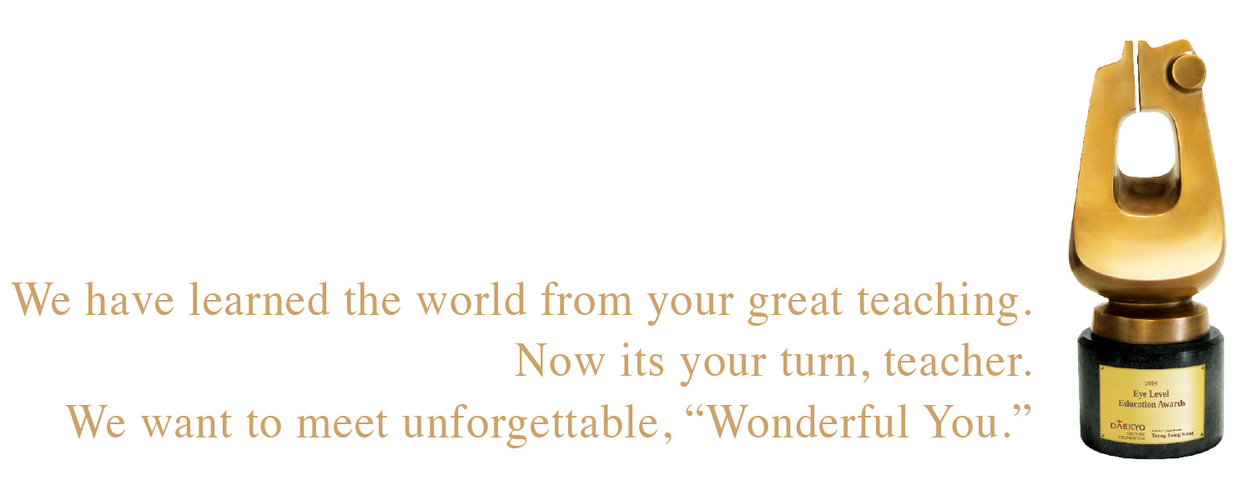


❖Recommendation Category
: The United States □ / Indonesia □ / Malaysia □ / Hong Kong □ (Please check corresponding box)
Nominee | Name |  | (Last Name) |  |  |  | Resident Registration Number |  |  |  |  |  | No. - -
Nominee |  |  | (First Name) |  |  |  |  |  |  |  |  |  | No. - -
Nominee | Organization |  |  |  |  |  | Position |  |  |  |  |  | No. - -
Nominee | Contact Information | Home  Address | ( - ) Tel ( ) - |  |  |  |  |  |  |  |  |  | Photo
Nominee | Contact Information | Office  Address | ( - ) Tel ( ) - |  |  |  |  |  |  |  |  |  | Photo
Nominee | Contact Information | Cellular  Phone |  |  |  | E-mail |  |  |  |  | Teaching  Experience |  | Year  Month
Reason for recommendation
Recommender | Name |  |  | Organization | Relationship |  |  |  | Contact Information |  |  | Confirmation
Recommender |  |  |  |  |  |  |  |  |  |  |  | (Signature)
Recommender |  |  |  |  |  |  |  |  |  |  |  | (Signature)
Recommender |  |  |  |  |  |  |  |  |  |  |  | (Signature)
Recommender |  |  |  |  |  |  |  |  |  |  |  | (Signature)
Recommender |  |  |  |  |  |  |  |  |  |  |  | (Signature)

I recommend the above person as a nominee of the Eye Level Education Awards
and I confirm that all statements made above are true.
. . 2014
To DAEKYO Culture Foundation
(Continued to back page)

※ Please fill out the following information as precisely as possible.
No. - -
Family Background | Name | Relationship | Occupation
Education | Period | Name of School | Major | Degree
Education | ~
Education | ~
Education | ~
Work Experience | Period | Organization | Job Description | Position
Work Experience | ~
Work Experience | ~
Work Experience | ~
Work Experience | ~
Work Experience | ~
Work Experience | ~
Work Experience | ~
Work Experience | ~
Work Experience | ~
Work Experience | ~
Awards | Date Awarded | Awards Name | Awards Giving Body
Awards | . .
Awards | . .
Awards | . .
Awards | . .
Certificate | Issue Date | Type of certificate | Issued by
Certificate | . .
Certificate | . .
Certificate | . .

